iMagic : Acquire images from Ultrasound machine for post processing.

Acquiring images from both DICOM and non-DICOM images from ultrasound machines for storage, analysis and distribution.

Key Features :

- Intuitive viewing and post processing of images
- Template based reporting with images and reports
- Distribution thro’ CD, pendrive
- Image transfer to any PACS

Features :

- Adding Patient Information

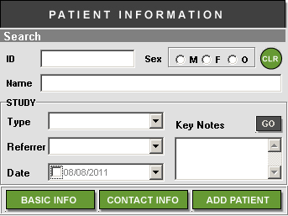

Allows to add patient information thro’ DICOM / Direct Manual entry

- Adding Study
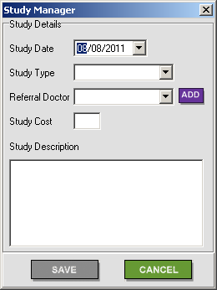
Allows to add study information thro’ DICOM / Direct Manual entry

- Image Acquisition

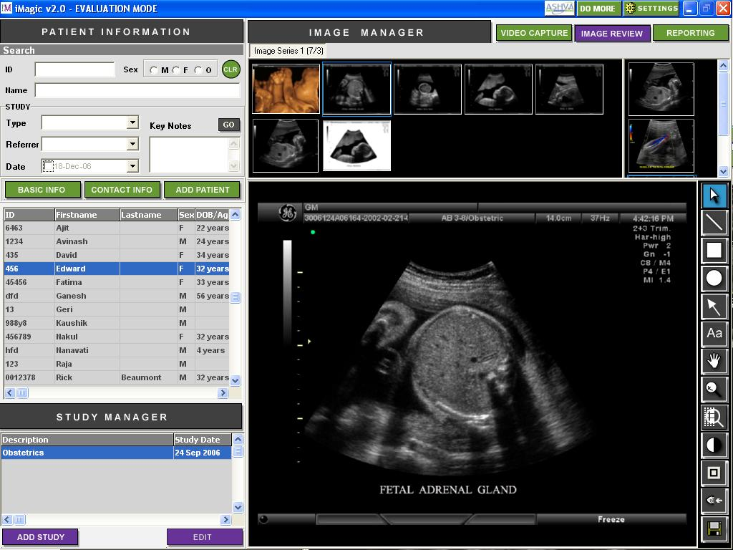

Allows to acquire single frames and sequences from Non-DICOM and DICOM images. Presets and footswitch integration enabled.

- Image Manipulation - Single Frame Images & sequences

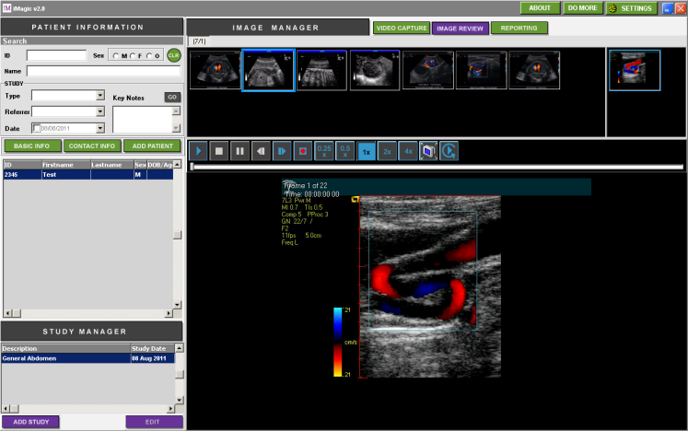

Thumbnail display of single frames & sequences.
Play sequences in continuous / frame by frame mode.
Extract single frames from sequences.
Edit sequences for user-defined playback options.

- REPORTING

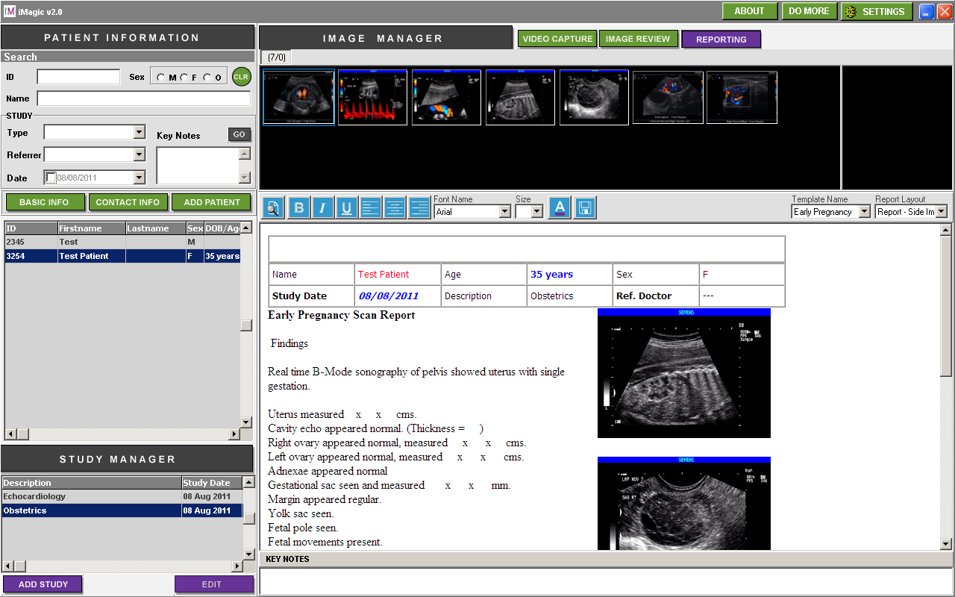

User-defined customizable report templates.
Multiple report templates for each study.
Drag and drop images for reporting.
Insert important reference images in text layout.
User-defined tabular forms for measurements and biometry reporting.

6.Report Distribution

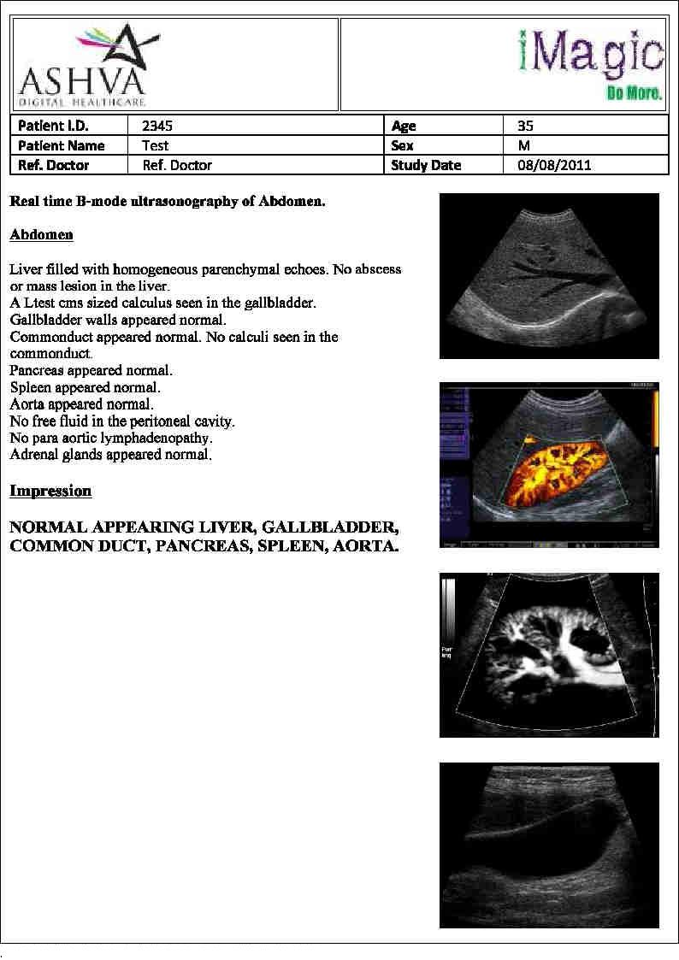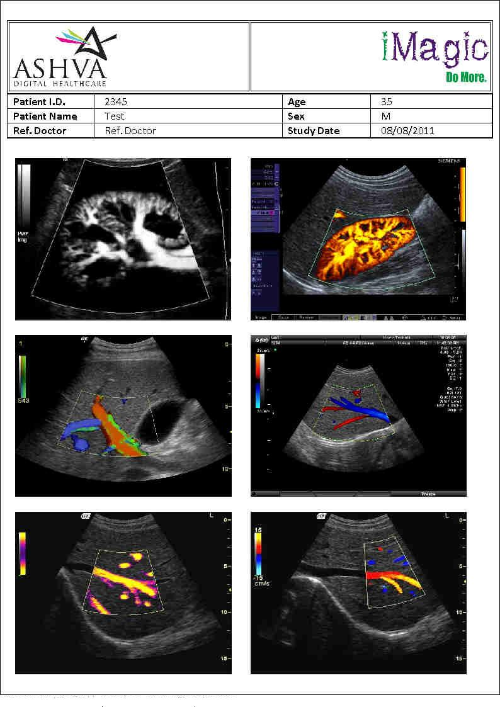
Reports can be written on a CD / saved to Disk / Printed on plain/pre-printed stationary /e-mailed / exported to Power-point. Images can be exported in multiple formats and saved on disk.

- QUERY Facility

Ability to query based on key image, gender, type, referral doctor, key notes, study date, study type available.

